**AP Chemistry** Name___________________________

Unit 2 Review

Things you need to have a thorough understanding of (all topics covered in Honors Chemistry and so far in this class are fair game):

• Types of Subatomic Particles

• The Nucleus

• Mass Spectroscopy and Isotopes

• Stability of the Nucleus

• Atomic Structure

• Rutherford Experiment

• Cathode Ray Experiments

• Atomic Structure Terms

• Electromagnetic Radiation

• Quantization of Energy

• Photoelectric Effect

• PES data

• Bohr Atom

• Spectroscopy

• Orbital Model of Atom

• Aufbau Diagram

• Paramagnetism

• Quantum Model

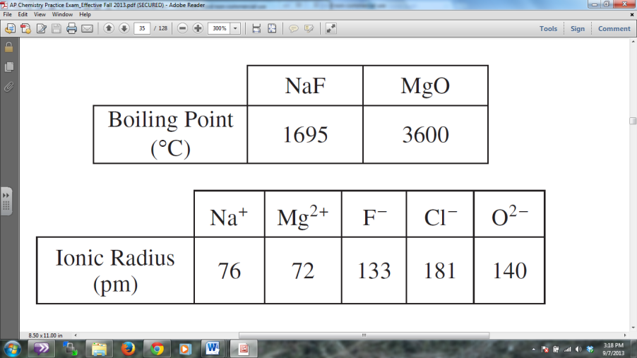

1. Based on the data in the tables above, which of the following statements provides the best prediction for the boiling point of NaCl ?
   1. NaCl will have a lower boiling point than NaF because the coulombic attractions are weaker in NaCl than in NaF .
   2. NaCl will have a boiling point between that of NaF and MgO because the covalent character of the bonds in NaCl is intermediate between that of MgO and NaF.
   3. NaCl will have a higher boiling point than MgO because the ions are spaced farther apart in NaCl .
   4. NaCl will have a higher boiling point than MgO because the energy required to transfer electrons from the anion to the cation is larger in NaCl than in MgO .

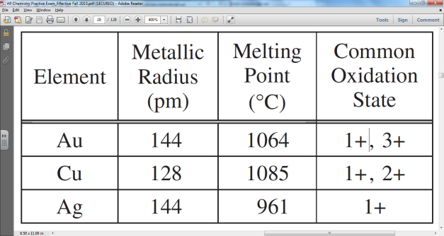

1. To make Au stronger and harder, it is often alloyed with other metals, such as Cu and Ag. Consider two alloys, one of Au and Cu and one of Au and Ag, each with the same mole fraction of Au. If the Au/Cu alloy is harder than the Au/Ag alloy, then which of the following is the best explanation based on the information in the table above?
   1. Cu has two common oxidation states, but Ag has only one.
   2. Cu has a higher melting point than Au has, but Ag has a lower melting point than Au has.
   3. Cu atoms are smaller than Ag atoms, thus they interfere more with the displacement of atoms in the alloy.
   4. Cu atoms are less polarizable than are Au or Ag atoms, thus Cu has weaker interparticle forces.

The emission spectrum of hydrogen consists of several series of sharp emission lines in the ultraviolet (Lyman series n=_ to n=1) in the visible (Balmer series n=_ to n=2) and in the infrared (Paschen series n=_ to n=3, Brackett series n=_ to n=4, etc.) regions of the spectrum.

(a) What feature of the electronic energies of the hydrogen atom explains why the emission spectrum consists of discrete wavelength rather than a continuum wavelength?

(b) Account for the existence of several series of lines in the spectrum. What quantity distinguishes one series of lines from another?

(c) Draw an electronic energy level diagram for the hydrogen atom and indicate on it the transition corresponding to the line of lowest frequency in the Balmer series.

(d) What is the difference between an emission spectrum and an absorption spectrum? Explain why the absorption spectrum of atomic hydrogen at room temperature has only the lines of the Lyman series.

1981D Answer:

(a) 1pt: Any of the following:

Quantized energy levels. Discrete energies.

Wave properties of electron result in discrete energy state.

(b) 2pts: An electron in an excited-state atom can go to any of several lower energy states.

The lines in each series represents shifts from several higher energy states to a single lower energy state, identified by the same principal quantum number or energy.

(c) 2 pts:



(d) 3pts: Emission spectra obtained when electrons in excited atoms drop to lower energy levels.

Absorption spectra obtained when electrons in atoms in ground (or lower energy) state absorb electromagnetic radiation and move to higher energy states.

H atoms at 25°C are in lowest electronic energy state (n = 1) and so the only absorptions will result from electrons moving from n = 1 to higher levels.