Honors Chemistry II Name___________________________
Unit 4 Review

Things you need to have a thorough understanding of (all topics covered in Honors Chemistry and in this class so far are fair game):

- Types of Covalent Bonds
- Nonpolar Covalent Bonds
- Polar Covalent Bonds
- Coordinate Covalent Bonds - Lewis
- Acids and Lewis Bases
- Lewis Structures
- Resonance
- Hybridization
- Molecular Geometry
- Energy Effects on Molecules
- Isomerism
- Functional Groups
- Interactions of Functional Groups
- Classification of Molecules
- Intermolecular Interactions
- Dipole moments
- Types of Compounds
- Properties of Metallic, Molecular,
- Macromolecular and Ionic Compounds

The following three questions refer to the following diatomic species.
(A) Li₂ (B) B₂ (C) N₂
(D) O₂ (E) F₂

- Has the largest bond–dissociation energy
- Has a bond order of 2
- Contains 1 sigma (σ) and 2 pi (π) bonds

X CH₃–CH₂–CH₂–CH₂–CH₃
Y CH₃–CH₂–CH₂–CH₂–OH
Z HO–CH₂–CH₂–CH₂–OH
- Based on concepts of polarity and hydrogen bonding, which of the following sequences correctly lists the compounds above in the order of their increasing solubility in water?
(A) Z < Y < X (B) Y < Z < X
(C) Y < X < Z (D) X < Z < Y
(E) X < Y < Z

20125
Your responses to these questions will be scored on the basis of the accuracy and relevance of the information cited. Explanations should be clear and well organized. Examples and equations may be included in your responses where appropriate. Specific answers are preferable to broad, diffuse responses.
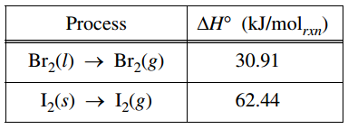
At 298 K and 1 atm, the standard state of Br₂ is a liquid, whereas the standard state of I₂ is a solid. The enthalpy changes for the formation of Br₂(g) and I₂(g) from these elemental forms at 298 K and 1 atm are given in the table above.
(a) Explain why ΔH° for the formation of I₂(g) from I₂(s) is larger than ΔH° for the formation of Br₂(g) from Br₂(l). In your explanation identify the type of particle interactions involved and a reason for the difference in magnitude of those interactions.

(b) Predict which of the two processes shown in the table has the greater change in entropy. Justify your prediction.

(c) I₂(s) and Br₂(l) can react to form the compound IBr(l). Predict which would have the greater molar enthalpy of vaporization, IBr(l) or Br₂(l). Justify your prediction.

An experiment is performed to compare the solubilities of I₂(s) in different solvents, water and hexane (C₆H₁₄). A student adds 2 mL of H₂O and 2 mL of C₆H₁₄ to a test tube. Because H₂O and C₆H₁₄ are immiscible, two layers are observed in the test tube. The student drops a small, purple crystal of I₂(s) into the test tube, which is then corked and inverted several times. The C₆H₁₄ layer becomes light purple, while the H₂O layer remains virtually colorless.
(d) Explain why the hexane layer is light purple while the water layer is virtually colorless. Your explanation should reference the relative strengths of interactions between molecules of I₂ and the solvents H₂O and C₆H₁₄, and the reasons for the differences.

The student then adds a small crystal of KI(s) to the test tube. The test tube is corked and inverted several times. The I⁻ ion reacts with I₂ to form the I₃⁻ ion, a linear species.
(i) In the box below, draw the complete Lewis electron-dot diagram for the I₃⁻ ion.

(ii) In which layer, water or hexane, would the concentration of I₃⁻ be higher? Explain.
2006B6
The species represented below all have the same number of chlorine atoms attached to the central atom.
GeCl₄ SeCl₄ ICl₄⁻ ICl₄⁺
- Draw the Lewis structure (electron-dot diagram) of each of the four species. Show all valence electrons in your structures.

- On the basis of the Lewis structures drawn in part (a), answer the following questions about the particular species indicated.
  - What is the Cl-Ge-Cl bond angle in GeCl₄?

  - Is SeCl₄ polar? Explain.

  - What is the hybridization of the I atom in ICl₄⁻ ?

  - What is the geometric shape formed by the atoms in ICl₄⁺ ?

Key:

2006B6
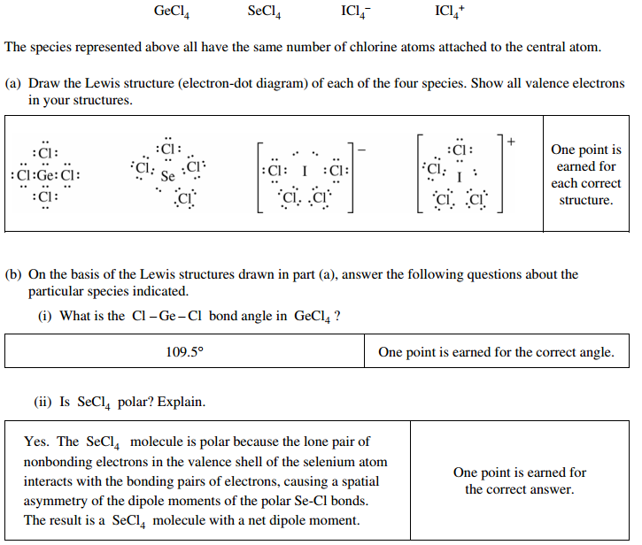
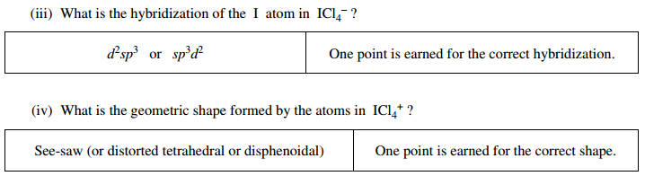

20125
