Honors Chemistry II Name___________________________
Unit 3 Review

Things you need to have a thorough understanding of (all topics covered in Honors Chemistry and so far in this class are fair game):

- Atomic Properties
- Periodic Law
- Elemental Properties
- Types of Bonds
- Metallic Bonding
- Properties of Group One
- Properties of Period Two
- Metals vs. Non Metals
- Multiple Oxidation States of Transition Metals
- Ionic Bonding
- Ionic Bonding and Potential Energy Diagrams
- Energy of Formation of Ionic Compounds
- Lattice energy

Questions 1-3

a. O c. Rb e. N
b. La d. Mg

1. What is the most electronegative element?
2. Which element exhibits the greatest number of different oxidation states?
3. Which of the elements above has the smallest ionic radius for its most commonly found ion?

4. The correct name for Na₃[CoF₆] is __________.
- trisodium hexakisfluorocobalt(III)
- trisodium hexakisfluorocobalt(II)
- trisodium hexakisfluorocobalt(IV)
- sodium hexafluorocobaltate(III)
- sodium hexafluorocobaltate(IV)

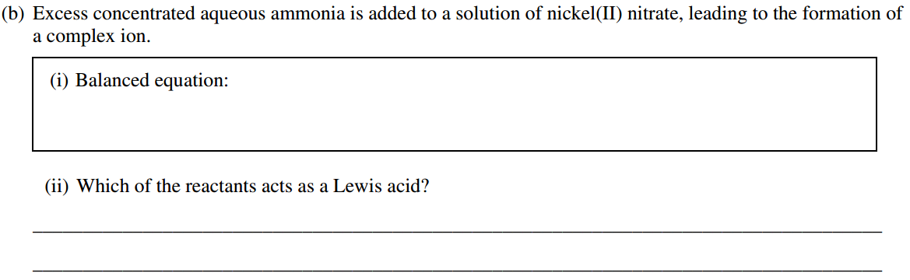

Answer the following questions related to sulfur and one of its compounds.
(a) Consider the two chemical species S and S²⁻.
(i) Write the electron configuration (e.g., 1s² 2s² …) of each species.
(ii) Explain why the radius of the S²⁻ ion is larger than the radius of the S atom.
(iii) Which of the two species would be attracted into a magnetic field? Explain.
(b) The S²⁻ ion is isoelectronic with the Ar atom. From which species, S²⁻ or Ar, is it easier to remove an electron? Explain.

1985 D
Properties of the chemical elements often show regular variation with respect to their positions in the periodic table.
(a) Describe the general trend in acid-base character of the oxides of the elements in the third period (Na to Ar). Give examples of one acidic oxide and one basic oxide and show with equations how these oxides react with water.
(b) How does the oxidizing strength of the halogen elements vary down the group? Account for this trend.
(c) How does the reducing strength of the alkali metals vary down the group? Account for this trend.

Here’s a good review question. I wish I had found it before the last test.

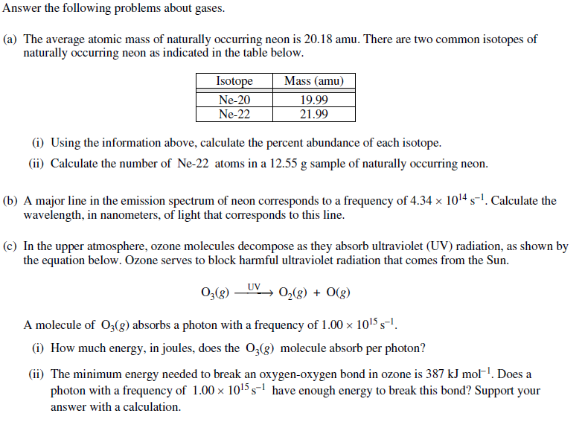

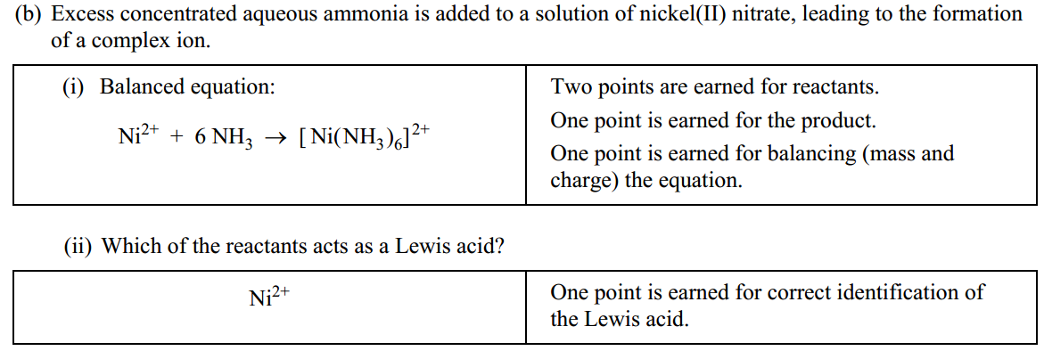

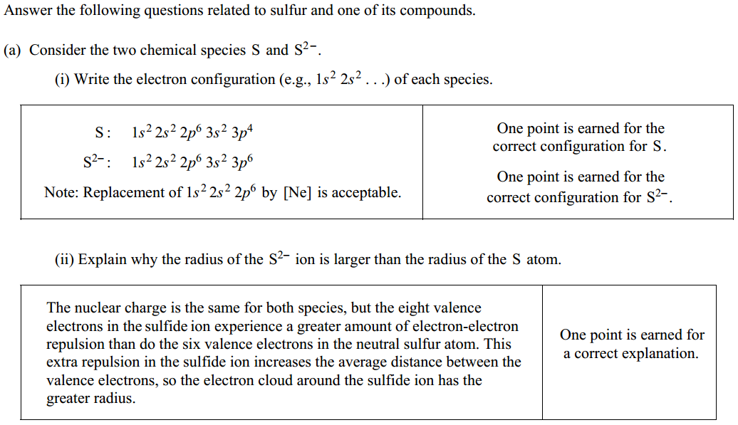
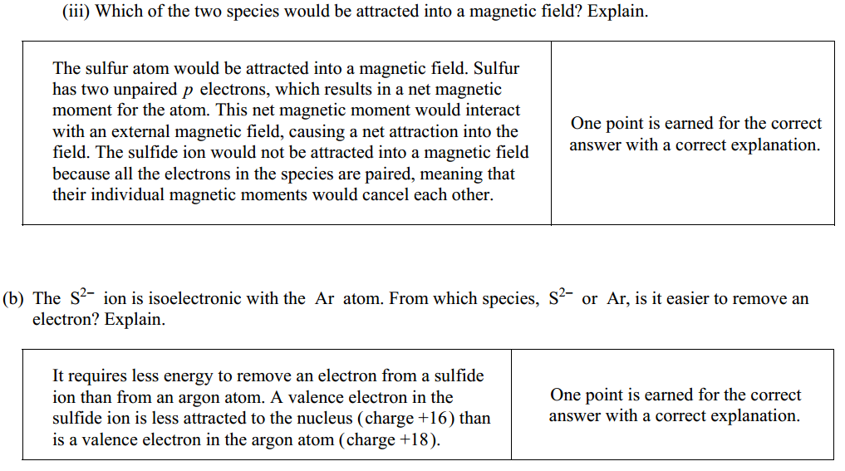

1985 D Answer:
(a) Oxides at left are basic and become less basic / more acidic as one moves to the right.
Basic oxide: Na₂O + 2 H₂O → 2 Na⁺ + 2 OH⁻ or: MgO + H₂O → Mg(OH)₂
Acidic oxide: any one of the oxides of Cl, S, or P
SO₂ + H₂O → H₂SO₃ (or equivalent for another oxide)
(b) Oxidizing strengths of halogen elements decrease down the group. Since atoms get larger down the group, the attraction for electrons decreases and oxidizing strength decreases.
(c) Reducing strengths of alkali metals increases down the group. Since atoms get larger down the group, loss of outer electrons is easier and reducing strength increases.

