**AP Chemistry** Name___________________________

Unit 13 Review – Electrochemistry

Things you need to have a thorough understanding of (all topics covered in Honors Chemistry and in this class so far are fair game): *(Italicized terms are not supposed to be tested by college board on the current AP Chem test and will not be points of focus in my instruction or the test for this unit.)*

* Oxidation and Reduction
* Types of electrochemical cells
* Voltaic cells
* Cell Potentials
* Concentration dependence of E
* *Nernst Equation*
* Cell potentials and Equilibrium
* Metal Electrodes
* Reference Electrodes
* Indicator electrodes
* Applications of Voltaic Cells
* Electrolysis
* Faraday’s Law
* Electrolytic Cells
* Order of reduction (determine which of two substances is reduced)
* Applications of Electrolytic cells
* Gibbs Free energy Equation (Free Work)
* Relationship of Equilibrium and Q
* Relationship to E

1. Which of the following expressions is correct for the maximum mass of copper, in grams, that could be plated out by electrolyzing aqueous CuCl2 for 16 hours at a constant current of 3.0 amperes? (1 faraday = 96,500 coulombs)

(A) [(16)(3,600)(3.0)(63.55)(2)] / (96,500)  
(B) [(16)(3,600)(3.0)(63.55)] / [(96,500)(2)]  
(C) [(16)(3,600)(3.0)(63.55)] / (96,500)  
(D) [(16)(60)(3.0)(96,500)(2)] / (63.55)  
(E) [(16)(60)(3.0)(96,500)] / [(63.55)(2)]

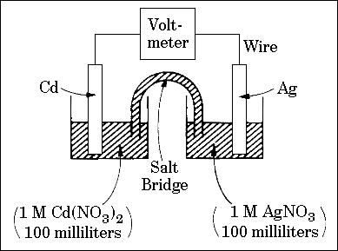

The answer choices below will be used for the following four questions. The spontaneous reaction that occurs when the cell above operates is:

2Ag+ + Cd(s) ---> 2 Ag(s) + Cd2+

(A) Voltage increases.  
(B) Voltage decreases.  
(C) Voltage becomes zero and remains at zero.  
(D) No change in voltage occurs.  
(E) Direction of voltage change cannot be predicted without additional information.

Which of the above occurs for each of the following circumstances?

1. A 50-milliliter sample of a 2-molar Cd(NO3)2 solution is added to the left beaker.
2. The silver electrode is made larger.
3. The salt bridge is replaced by a platinum wire
4. Current is allowed to flow for 5 minutes

Cu(s) + 2 Ag+ ---> Cu2+ + 2 Ag(s)

1. If the equilibrium constant for the reaction above is 3.7 x 1015, which of the following correctly describes the standard voltage, E°, and the standard free energy change, ∆G°, for this reaction?

(A) E° is positive and ∆G° is negative.  
(B) E° is negative and ∆G° is positive.  
(C) E° and ∆G° are both positive.  
(D) E° and ∆G° are both negative.  
(E) E° and ∆G° are both zero

1. As steady current of 10 amperes in passed through an aluminum-production cell for 15 minutes. Which of the following is the correct expression for calculating the number of grams of aluminum produced? (1 faraday = 96,500 coulombs)

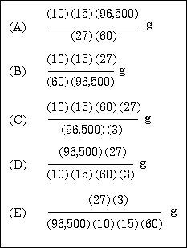

1. What is the oxidation number of bromine in the BrO3- ion?

A) -1

B) +1

C) +3

D) +5

E) +7

1. Which element is reduced in the reaction below?

Fe+2 + H+ + Cr2O7-2 → Fe+3 + Cr+3 + H2O

A) Fe

B) Cr

C) O

D) H

1. Which one of the following reactions is a redox reaction?

A) NaOH + HCl → NaCl + H2O

B) Pb2+ + 2Cl- → PbCl2

C) AgNO3 + HCl → HNO3 + AgCl

D) None of the above is a redox reaction.

1. What is the coefficient of the permanganate ion when the following equation is balanced?

MnO4- + Br- → Mn2+ + Br2 (acidic solution)

A) 1

B) 2

C) 3

D) 5

E) 4

1. Which transformation could take place at the anode of an electrochemical cell?

A) NO → NO3-

B) CO2 → Cr2O42-

C) VO2+ → VO2+

D) H2AsO4 → H3AsO3

E) O2 → H2O2

**Table 20.2**

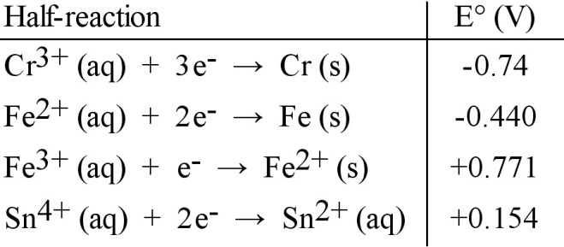

1. Which of the following reactions will occur spontaneously as written?

A) Sn4+ (aq) + Fe3+ (aq) → Sn2+ (aq) + Fe2+ (aq)

B) 3Fe (s) + 2Cr3+ (aq) → 2Cr (s) + 3Fe2+ (aq)

C) Sn4+ (aq) + Fe2+ (aq) → Sn2+ (aq) + Fe (s)

D) 3Sn4+ (aq) + 2Cr (s) → 2Cr3+ (aq) + 3Sn2+ (aq)

E) 3Fe2+ (aq) → Fe (s) + 2Fe3+ (aq)

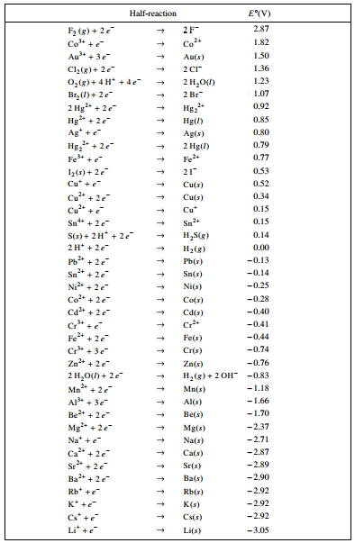

1. In a laboratory experiment, Pb and an unknown metal Q were immersed in solutions containing aqueous ions of unknown metals Q and X. The following reactions summarize the observations.

Observation 1: Pb*(s)* + X2+*(aq)* 🡪 Pb2+*(aq)* + X*(s)*

Observation 2: Q*(s)* + X2+*(aq)* 🡪 no reaction

Observation 3: Pb*(s)* + Q2+*(aq)* 🡪 Pb2+*(aq)* + Q*(s)*

(a) On the basis of the reactions indicated above, arrange the three metals, Pb, Q, X, in order from least reactive to the most reactive on the lines provided below.



The diagram below shows an electrochemical cell that is constructed with a Pb electrode immersed in 100. mL of 1.0 M Pb(NO3)2*(aq)* and an electrode made of metal X immersed in 100. mL of 1.0 M X(NO3)2*(aq)*. A salt bridge containing saturated aqueous KNO3 connects the anode compartment to the cathode compartment. The electrodes are connected to an external circuit containing a switch, which is open. When a voltmeter is connected to the circuit as shown, the reading on the voltmeter is 0.47 V. When the switch is closed, electrons flow through the switch from the Pb electrode toward the X electrode.

(b) Write the equation for the half-reaction that occurs at the anode.

(c) The value of the standard potential for the cell, *E°*, is 0.47 V.

(i) Determine the standard reduction potential for the half-reaction that occurs at the cathode.

(ii) Determine the identity of metal X.

(d) Describe what happens to the mass of each electrode as the cell operates.

(e) During a laboratory session, students set up the electrochemical cell shown above. For each of the following three scenarios, choose the correct value of the cell voltage and justify your choice.

(i) A student bumps the cell setup, resulting in the salt bridge losing contact with the solution in the cathode compartment. Is V equal to 0.47 or is V equal to 0? Justify your choice.

(ii) A student spills a small amount of 0.5 *M* Na2SO4*(aq)* into the compartment with the Pb electrode, resulting in the formation of a precipitate. Is V less than 0.47 or is V greater than 0.47? Justify your choice.

(iii) After the laboratory session is over, a student leaves the switch closed. The next day, the student opens the switch and reads the voltmeter. Is V less than 0.47 or is V equal to 0.47? Justify your choice.

#14 Answer

(a) Q (least reactive), X, Pb (most reactive)

(b) Pb 🡪 Pb2+ + 2 e-

(c) (i) 0.13 V + cathode = + 0.47 V, cathode = +0.34 V

(ii) Cu

(d) Pb loses mass, Cu gains mass

(e) (i) V = 0, no salt bridge, no current

(ii) V > 0.47, the SO42- reacts with the Pb2+ to create a ppt of PbSO4, thus decreasing the concentration of lead ions. This causes the oxidation half-reaction to increase in speed (LeChatelier shift) and increase in potential.

(iii) V < 0.47, the system moves toward equilibrium and the voltage drops as X2+ ion concentration at the cathode is diminished.