**Honors Chemistry II** Name___________________________

Unit 8 Review

Things you need to have a thorough understanding of (all topics covered in Honors Chemistry and in this class so far are fair game):

* Thermodynamics
* Conservation of energy
* State Functions
* Potential Energy
* Kinetic Energy
* Calorimetry
* Heat of Fusion
* Heat of Vaporization
* Specific Heat
* Heat of Dilution
* Heat of Solution
* Hess’s Law—direct and indirect
* Bond Dissociation Energies
* Gibbs Free Energy Equation

K(s) + ½ Cl2(g) → KCl(s) ΔHrxn° = −437 kJ/mol

The elements K and Cl react directly to form the compound KCl according to the equation above. Refer to the information above and the table below to answer the questions that follow.

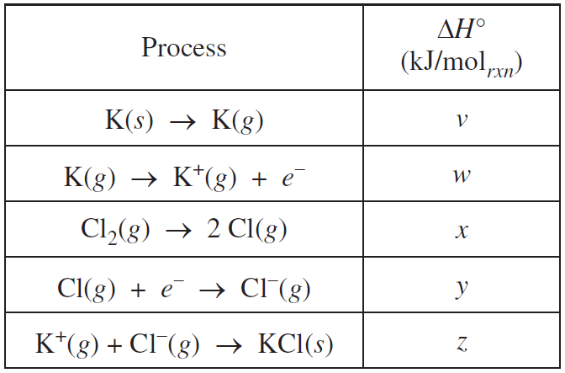

1. How much heat is released or absorbed when 0.050 mol of Cl2(g) is formed from KCl(s)?
   1. 87.4 kJ is released
   2. 43.7 kJ is released
   3. 43.7 kJ is absorbed
   4. 87.4 kJ is absorbed
2. What remains in the reaction vessel after equal masses of K(s) and Cl2(g) have reacted until either one or both of the reactants have been completely consumed?
   1. KCl only
   2. KCl and K only
   3. KCl and Cl2 only
   4. KCl , K, and Cl2
3. Which of the values of ∆H° for a process in the table is (are) less than zero (i.e., indicate(s) an exothermic process)?
   1. z only
   2. y and z only
   3. x, y, and z only
   4. w, x, y, and z
4. It is observed that the reaction producing KCl from its elements goes essentially to completion. Which of the following is a true statement about the thermodynamic favorability of the reaction?
   1. The reaction is favorable and driven by an enthalpy change only.
   2. The reaction is unfavorable and driven by an entropy change only.
   3. The reaction is favorable and driven by both enthalpy and entropy changes.
   4. The reaction is unfavorable due to both enthalpy and entropy changes.

Cl2(g) + 2 e− → 2 Cl−(g)

1. Which of the following expressions is equivalent to ∆H° for the reaction represented above?
   1. x + y
   2. x - y
   3. x + 2y
   4. 2x - y
2. A 100 g sample of a metal was heated to 100°C and then quickly transferred to an insulated container holding 100 g of water at 22°C. The temperature of the water rose to reach a final temperature of 35°C. Which of the following can be concluded?
   1. The metal temperature changed more than the water temperature did; therefore the metal lost more thermal energy than the water gained.
   2. The metal temperature changed more than the water temperature did, but the metal lost the same amount of thermal energy as the water gained.
   3. The metal temperature changed more than the water temperature did; therefore the heat capacity of the metal must be greater than the heat capacity of the water.
   4. The final temperature is less than the average starting temperature of the metal and the water; therefore the total energy of the metal and water decreased.

Free Response

2011 form B, question #3

Answer the following questions about glucose, C6H12O6, an important biochemical energy source.

(a) Write the empirical formula of glucose.

In many organisms, glucose is oxidized to carbon dioxide and water, as represented by the following equation.

C6H12O6*(s)* + 6 O2*(g)* → 6 CO2*(g)* + 6 H2O*(l)*

A 2.50 g sample of glucose and an excess of O2*(g)* were placed in a calorimeter. After the reaction was initiated and proceeded to completion, the total heat released by the reaction was calculated to be 39.0 kJ.

(b) Calculate the value of ∆*H*°, in kJ mol-1, for the combustion of glucose.

(c) When oxygen is not available, glucose can be oxidized by fermentation. In that process, ethanol and carbon dioxide are produced, as represented by the following equation.

C6H12O6*(s)* → 2 C2H5OH*(l)* + 2 CO2*(g)* ∆*H*° = -68.0 kJ mol-1 at 298 K

The value of the equilibrium constant, *Kp* for the reaction at 298 K is 8.9 × 1039.

(i) Calculate the value of the standard free-energy change, ∆*G*°, for the reaction at 298 K. Include units with your answer.

(ii) Calculate the value of the standard entropy change, ∆*S*°, in J K-1 mol-1, for the reaction at 298 K.

(iii) Indicate whether the equilibrium constant for the fermentation reaction increases, decreases, or remains the same if the temperature is increased. Justify your answer.

(d) Using your answer for part (b) and the information provided in part (c), calculate the value of ∆*H*° for the following reaction.

C2H5OH*(l)* + 3 O2*(g)* → 2 CO2*(g)* + 3 H2O*(l)*

2010 A

A student performs an experiment to determine the molar enthalpy of solution of urea, H2NCONH2. The student places 91.95 g of water at 25°C into a coffee-cup calorimeter and immerses a thermometer in the water.

After 50 s, the student adds 5.13 g of solid urea, also at 25°C, to the water and measures the temperature of the solution as the urea dissolves. A plot of the temperature data is shown in the graph below.



(a) Determine the change in temperature of the solution that results from the dissolution of the urea.

(b) According to the data, is the dissolution of urea in water an endothermic process or an exothermic process? Justify your answer.

(c) Assume that the specific heat capacity of the calorimeter is negligible and that the specific heat capacity of the solution of urea and water is 4.2 J g-1 °C-1 throughout the experiment.

(i) Calculate the heat of dissolution of the urea in joules.

(ii) Calculate the molar enthalpy of solution, ΔH of urea in kJ mol-1.

(d) Using the information in the table below, calculate the value of the molar entropy of solution, ΔS of urea at 298 K. Include units with your answer.

|  |  |
| --- | --- |
|  | Accepted Value |
| ΔHof urea | 14.0 kJ mol-1 |
| ΔGof urea | –6.9 kJ mol-1 |

(e) The student repeats the experiment and this time obtains a result for Δ*H*of urea that is 11 percent below the accepted value. Calculate the value of Δ*H* that the student obtained in this second trial.

(f) The student performs a third trial of the experiment but this time adds urea that has been taken directly from a refrigerator at 5°C. What effect, if any, would using the cold urea instead of urea at 25°C have on the experimentally obtained value of Δ*H*? Justify your answer.

2011B#3

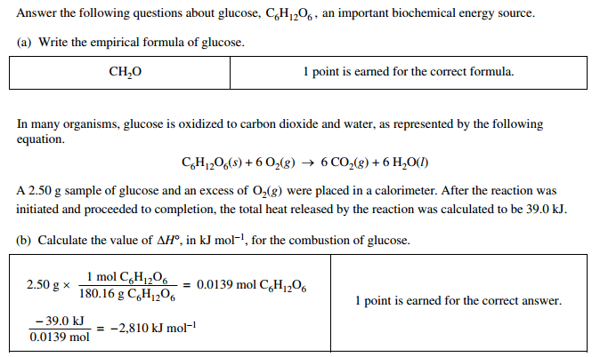

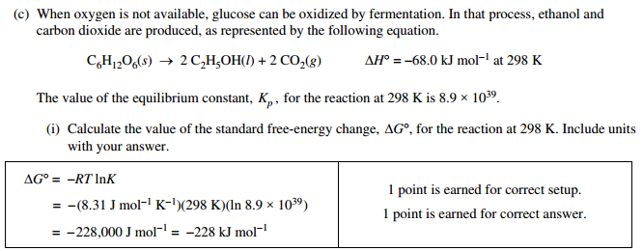

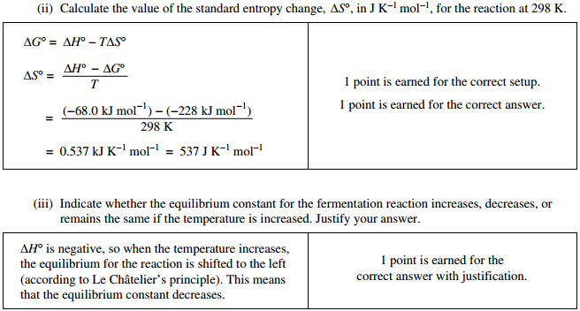

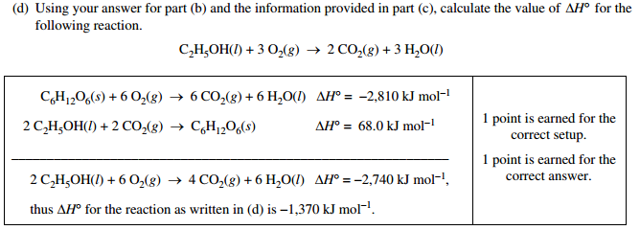

2010A#2

