Honors Chemistry II Name___________________________
Unit 6 Review

Things you need to have a thorough understanding of (all topics covered in Honors Chemistry and in this class so far are fair game):

- Naming Compounds
- Balancing Chemical Equations
- Types of Chemical Equations
- Types of Chemical Reactions
- Predicting Products based on stability and types
- Chemical Reactivity
- Reaction Types
  - Acid-base (Arrhenius, Bronsted-Lowry, Lewis)
  - Coordination Complex
  - Precipitation
  - Redox Reactions (simple), most are single replacements

- Which of the following particulate diagrams best shows the formation of water vapor from hydrogen gas and oxygen gas in a rigid container at 125°C?
  - 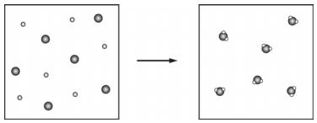
  - 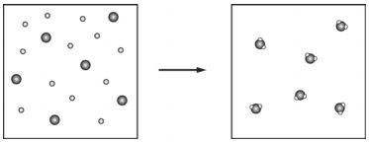
  - 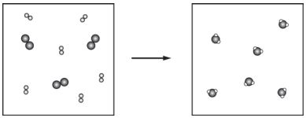
  - 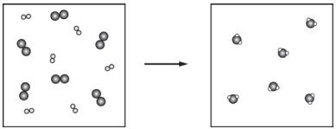
- What remains in the reaction vessel after equal masses of K(s) and Cl₂(g) have reacted until either one or both of the reactants have been completely consumed?
  - KCl only
  - KCl and K only
  - KCl and Cl₂ only
  - KCl, K, and Cl₂

Write balanced net ionic equations for the following reactions.
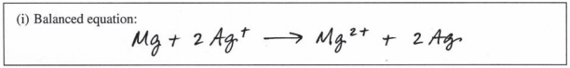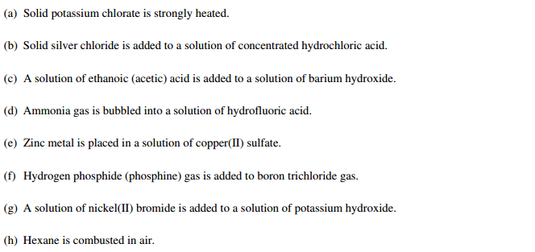

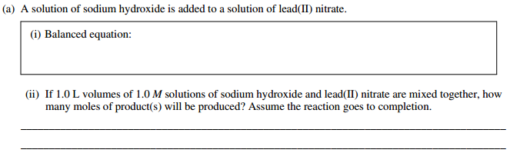
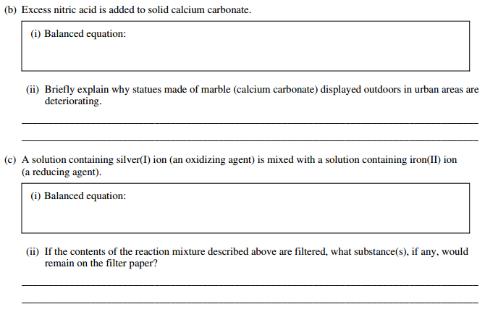
Key:
