Honors Chemistry II Name___________________________
Unit 7 Review

Things you need to have a thorough understanding of (all topics covered in Honors Chemistry and in this class so far are fair game):

- Law of Constant Composition and Calculations based on Law (i.e. percent composition)
- Using Moles to find a Quantity
- Stoichiometry
- Limiting Reagents
- Using Density
- Solution Terms
- Stoichiometry - Solutions

1. A compound contains 30. percent sulfur and 70. percent fluorine by mass. The empirical formula of the compound is
(A) SF
(B) SF₂
(C) SF₄
(D) SF₆
(E) S₂F

2. If 0.40 mol of H₂ and 0.15 mol of O₂ were to react as completely as possible to produce H₂O, what mass of reactant would remain?
(A) 0.20 g of H₂
(B) 0.40 g of H₂
(C) 3.2 g of O₂
(D) 4.0 g of O₂
(E) 4.4 g of O₂

3. ... Fe(OH)₂ + ... O₂ + ... H₂O ---> ... Fe(OH)₃
If 1 mole of O₂ oxidizes Fe(OH)₂ according to the reaction represented above, how many moles of Fe(OH)₃ can be formed?
(A) 2
(B) 3
(C) 4
(D) 5
(E) 6

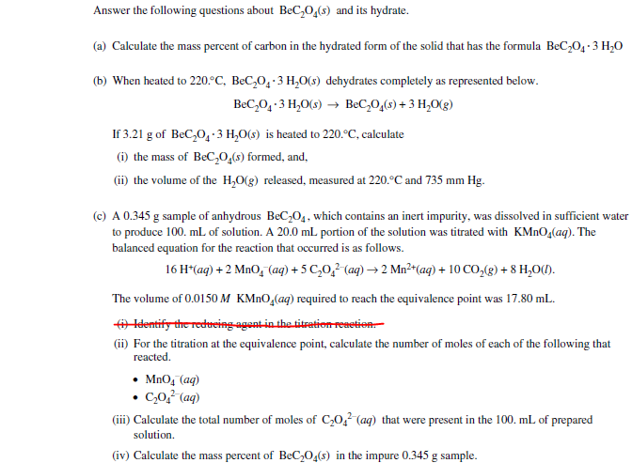

- #3 Answer the following questions about acetylsalicylic acid, the active ingredient in aspirin.

- The amount of acetylsalicylic acid in a single aspirin tablet is 325 mg, yet the tablet has a mass of 2.00 g. Calculate the mass percent of acetylsalicylic acid in the tablet.

- The elements contained in acetylsalicylic acid are hydrogen, carbon, and oxygen. The combustion of 3.00 g of the pure compound yields 1.200 g of water and 3.72 L of dry carbon dioxide, measured at 750. mm Hg and 25 ºC. Calculate the mass, in g of each element in the 3.00 g sample.

