**sp**

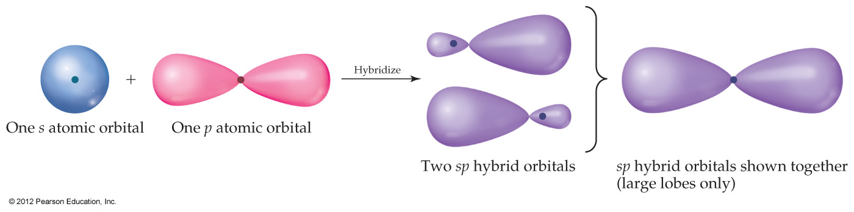

**sp2**

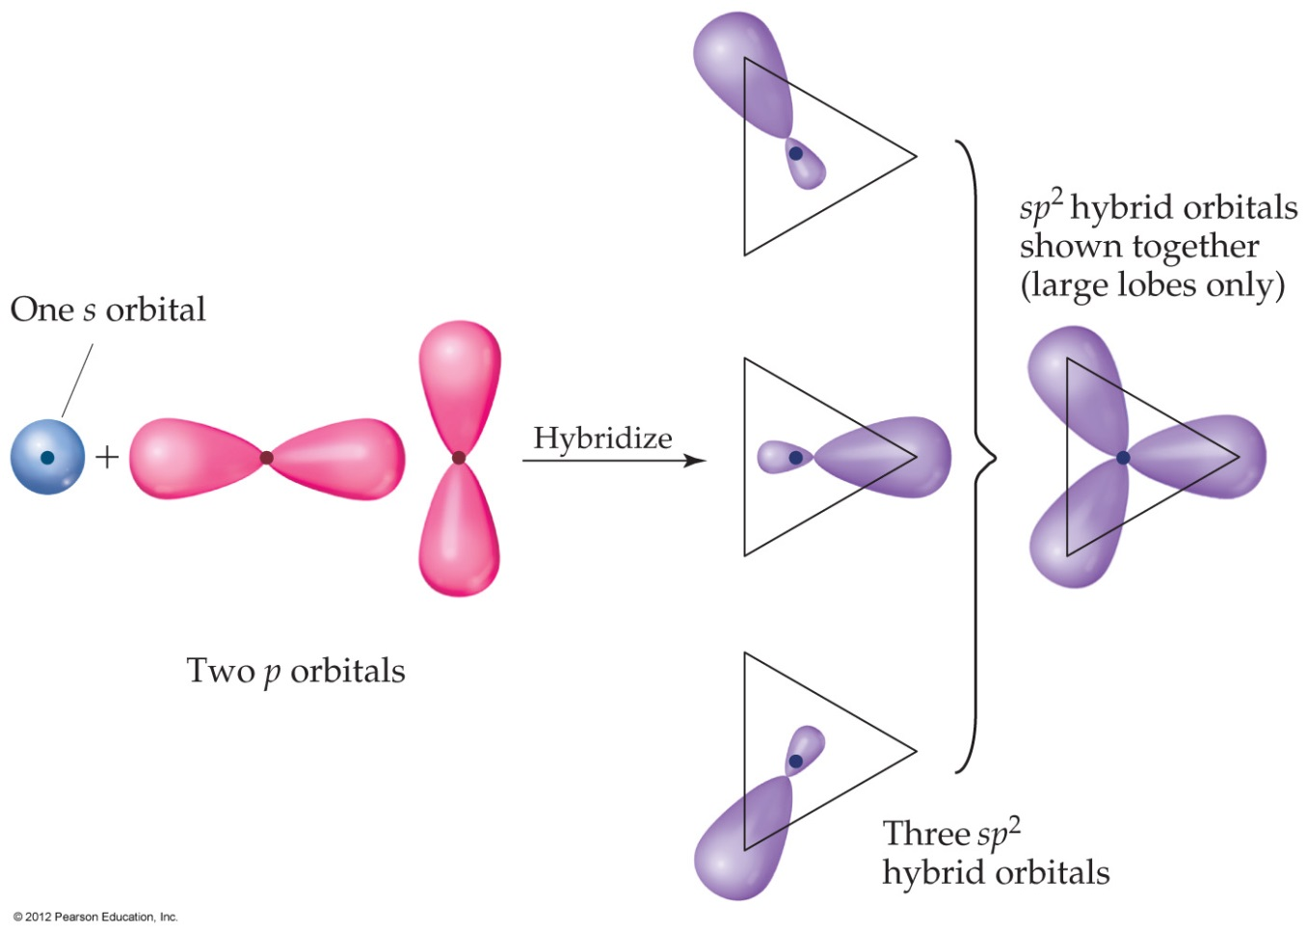

**sp3**

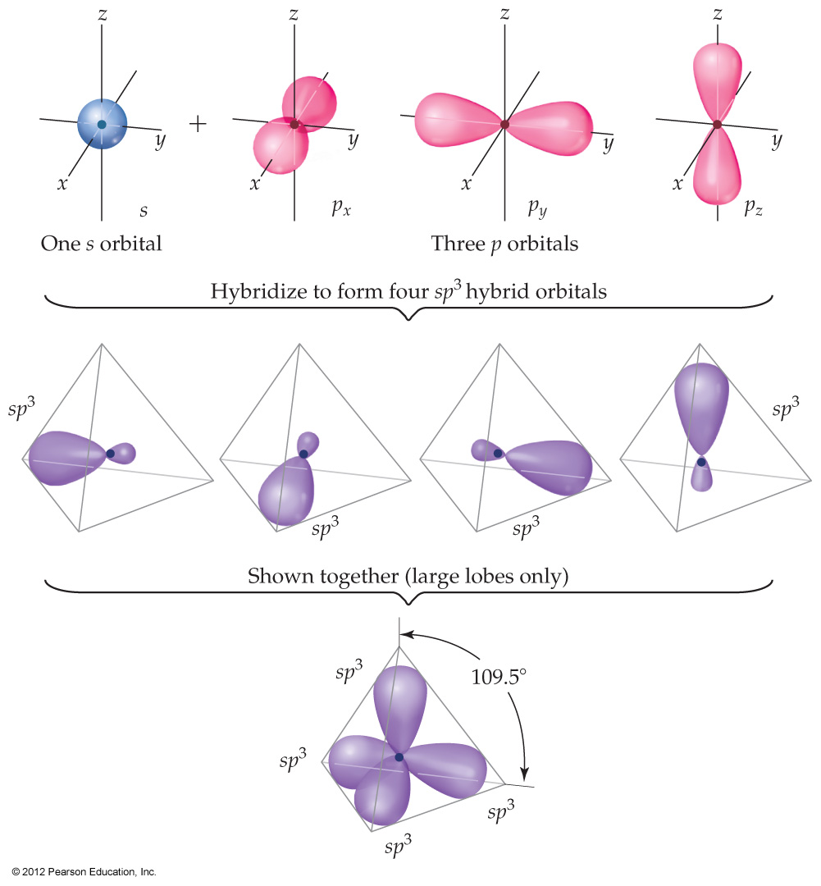

**Sigma (σ) and Pi (π) Bonds**

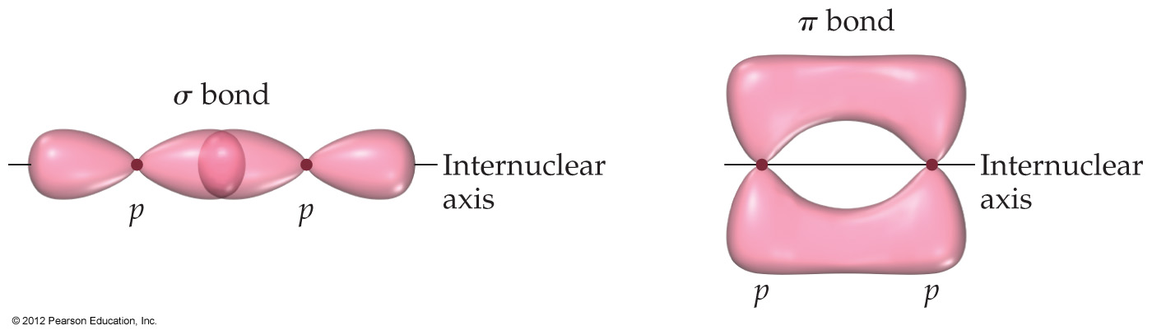

**Formaldehyde H2­CO**

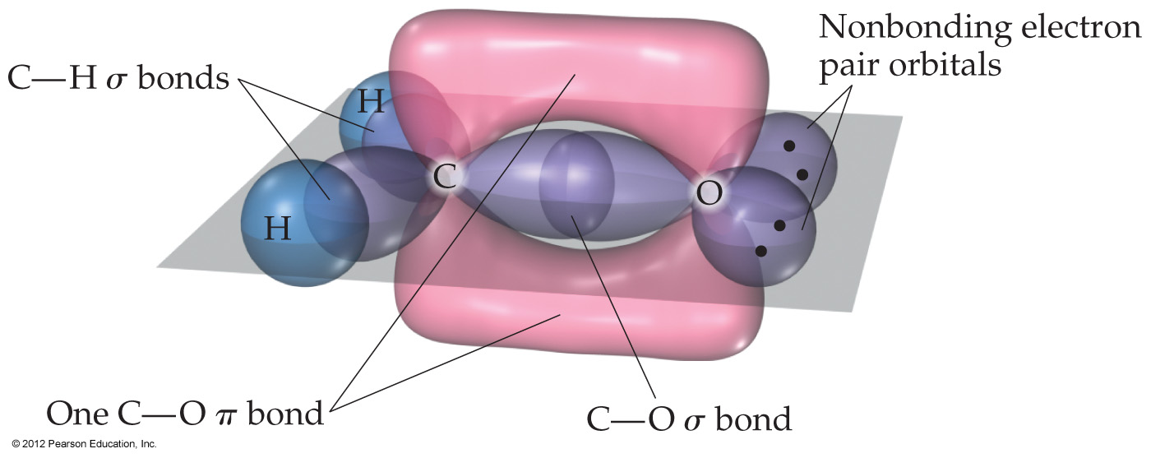

**Acetylene (C2H2)**

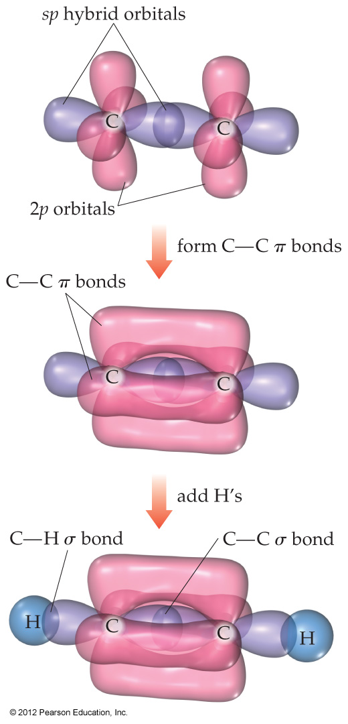

**Nitrate (NO3-)**

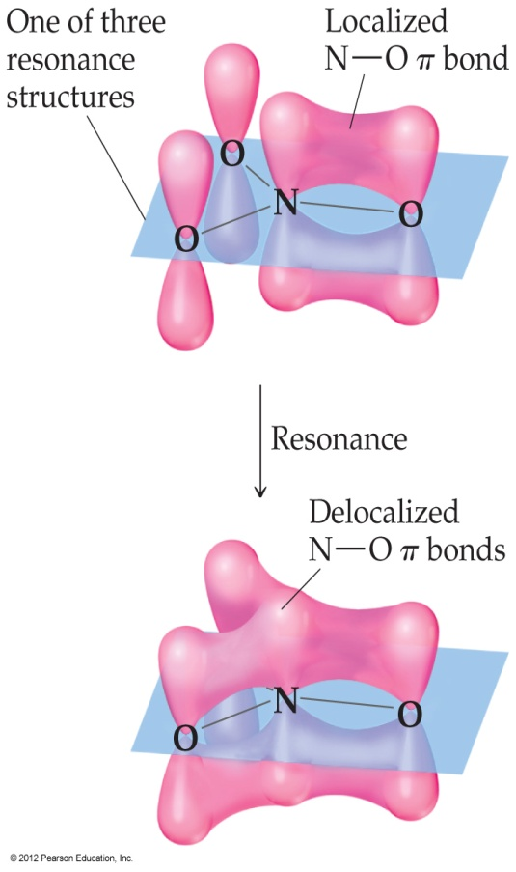

**Benzene (C6H6)**

